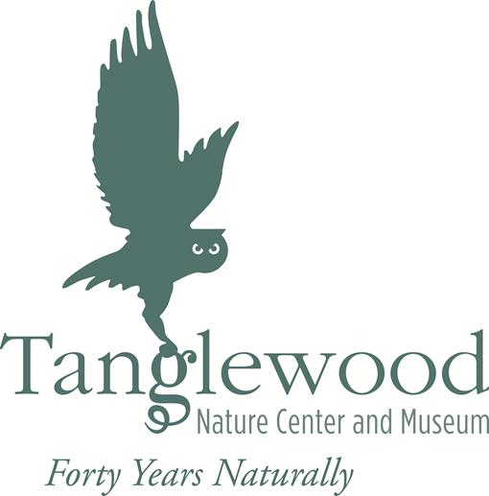

Current List of Programs for School and Community Groups
Audience: elementary school students, though many can be adapted for middle and high school students as well.

Please contact us if you have an idea for a different program, or would like to tailor an existing program to your curriculum!

Amazing Animals
This program highlights an animal from each of our five popular animal groups: a mammal, a bird, a reptile, an amphibian, and an arthropod. Learn about the distinctive features of each group while you get a varied look at some of Tanglewood's animal ambassadors.

Birds of Prey, Big and Small
Check out some of our bird residents! Program may include Sophie the Great-horned Owl, Mini the Cooper’s Hawk, Lucy the Barred Owl, Hank the Red-tailed Hawk, or Gridley the Merlin. Get up close and personal with these high-flying species and learn what makes birds special in the world of animals.

Breaking Out of Their Shells
Of course our owls and hawks were hatched from eggs, but students will learn that salamanders, turtles, snakes and insects also emerge from shells. This is a great springtime program, though it can be taught any time.

(continued)
How to Get There and What to Wear
Animals take advantage of a variety of ways to get from place to place. They walk, crawl, hop, skip, leap and fly. Learn how animals move in the wild, and why animals are covered with so many different kinds of "outfits". You might get to meet someone with long legs or no legs at all. How about someone that wears a fur coat? Or spikes on their back?

Lizards, Snakes, and Frogs
Learn about our fascinating and fun collection of reptiles and amphibians. The delightful cast of characters may include: a salamander, toad, leopard gecko, bearded dragon, bullfrog, and/or a large variety of turtles and snake species. Compare and contrast these animal groups in a very educational and interesting program.

Pond-ering Water
Students observe our ponds and wetlands and the organisms that call them home. From mammals to microscopic organisms, we've got it all. Book this program and find out why water is one of our most important and precious natural resources.

The A, "Bee", C's
Few animals work harder than bees, but what are they doing all day? And how do their efforts help other plants and animals, including us? Come and learn the basics of bee life and behavior, including a visit to our live beehive. Become a bee-liever!

What's Bugging You?
This program gives students a chance to learn about insects, spiders, and others that live in the soil, on the forest floor, and in the air. Arthropods outnumber all other animals on Earth, so education on this group is critical. The cast of characters encountered at Tanglewood might include Madagascar hissing cockroaches, a tarantula and other arthropods like millipedes and scorpions. We reinforce the similarities and differences of animals in the arthropod world.

